Ideation Phase
Brainstorm & Idea Prioritization Template

Date | 19 Feb. 2026
Team ID | LTVIP2026TMIDS83753
Project Name | Weather-Based Prediction of Wind Turbine Energy Output: A Next-Generation Approach to Renewable Energy Management

Brainstorm & Idea Prioritization Template:
Brainstorming provides an open environment where team members discuss and generate ideas to solve the problem of predicting wind turbine energy output. All ideas related to weather data, machine learning models, and system development are considered before selecting the best solution.
Use this template in your own brainstorming sessions so your team can unleash their imagination and start shaping concepts even if you're not sitting in the same room.
Reference: https://www.mural.co/templates/brainstorm-and-idea-prioritization
Step-1: Team Gathering, Collaboration and Select the Problem Statement
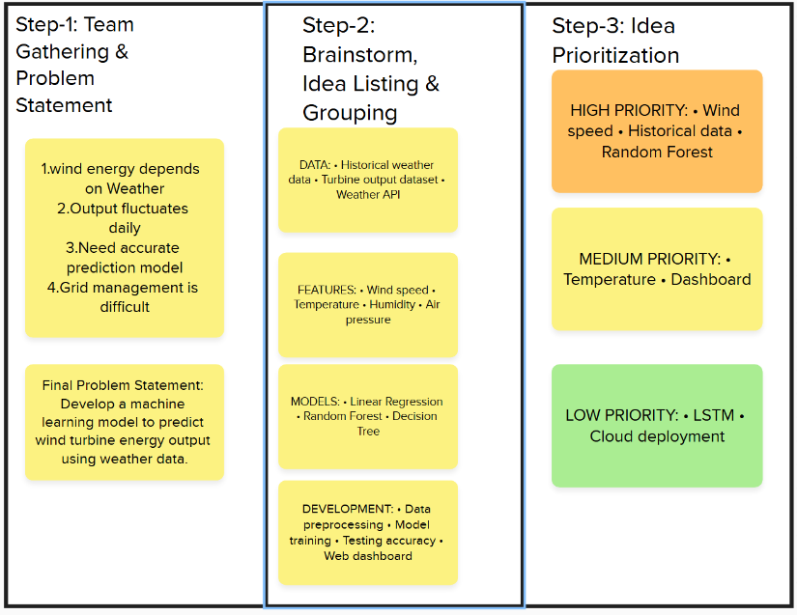

Step-2: Brainstorm, Idea Listing and Grouping
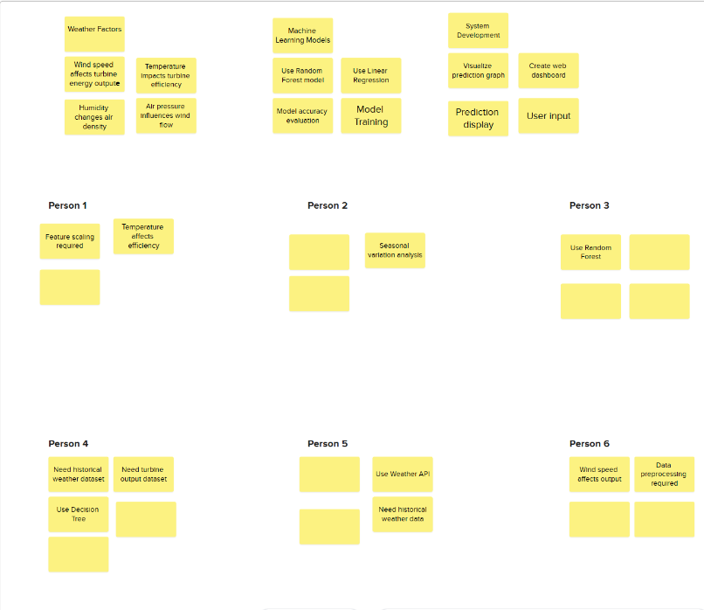

Step-3: Idea Prioritization
